**Unami Middle School Supply List for 7th Grade**

**Team Spark & Team Ignite**

*Required:*

* A “Case-It” 3-ring binder (with **pocket folders** for each subject. You will need one pocket folder left in your math classroom.)
* 1 large 3-ring zipped pencil case for the binder (students do not carry backpacks in middle school)
* Bound composition book for English
* 3 packs of post-it-notes (3x3)

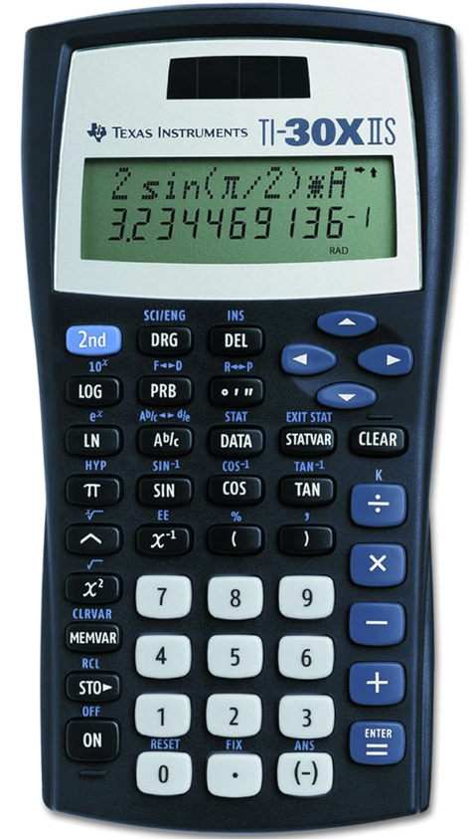

* 3 packs of notecards (3x5)
* 1 pack of colored pencils
* Multiple packs of pencils and 1 pack of pens (blue or black)
* Scientific calculator (TI 30XIIS preferred) – NOT a graphing calculator
* 1 pack of highlighters
* Two boxes of tissues to be given to Resource teacher
* Earbuds or headphones with microphone (cannot be an iPhone lightning connector)
* 1 Bluetooth mouse (optional)

PLEASE label all items! Teachers often find materials left behind in classrooms that are never claimed. Additionally, some items will need to be replenished throughout the school year (notebook paper, pens/pencils, etc.). Thank you for helping to prepare your child for a great school year! We’re excited to begin this rewarding work.